AideMoris: Assisting Senior Citizens in Mauritius During Home Confinement
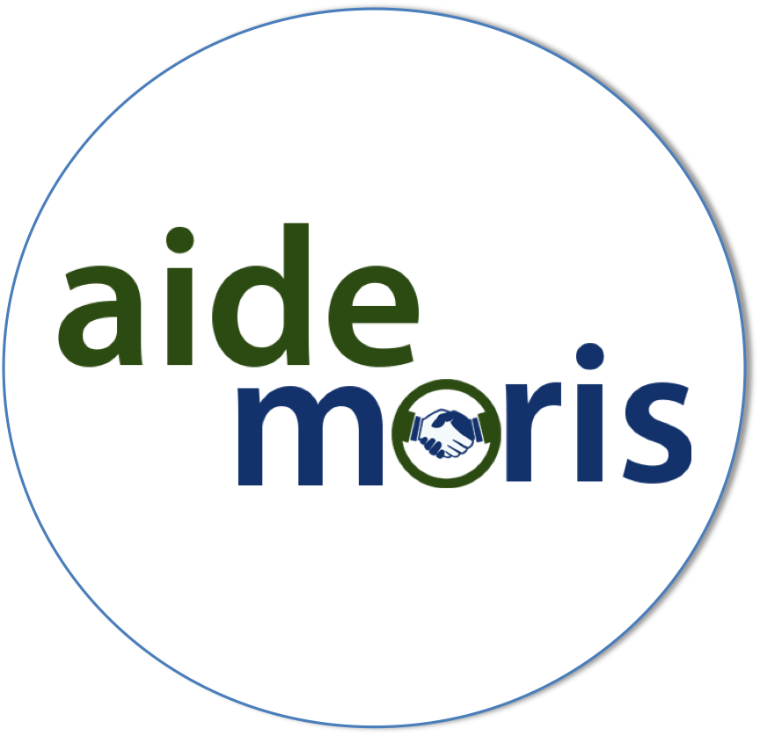
The aim of this project is to develop a mobile application system that can assist senior citizens in obtaining food and medical supplies or other basic assistance during a curfew, lock down or confinement while staying safe at home. This project is innovative in 1) its ability to bridge the gap between non-technology senior citizens and online services accessible on smart phones 2) linking NGOs to needy senior citizens in an efficient and secured manner 3) quickly reach out to a maximum number of people facilitating assistance from neighborhood volunteers to adhere to travel restriction during curfew or lock down. This project involves close research collaboration with the University of Mauritius and part funding from the MRIC.

Project Value (Rs):  MUR 600,000 | Amount funded by MRIC (Rs:)  MUR 350,000.
Duration: 4 Months

