Inline | 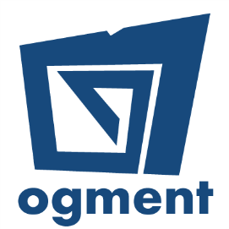

Inline QOMS (Queue & Occupancy Management System) is a smart, cloud-based queueing system, which monitors data related to queues in real time, and collect customer feedback.

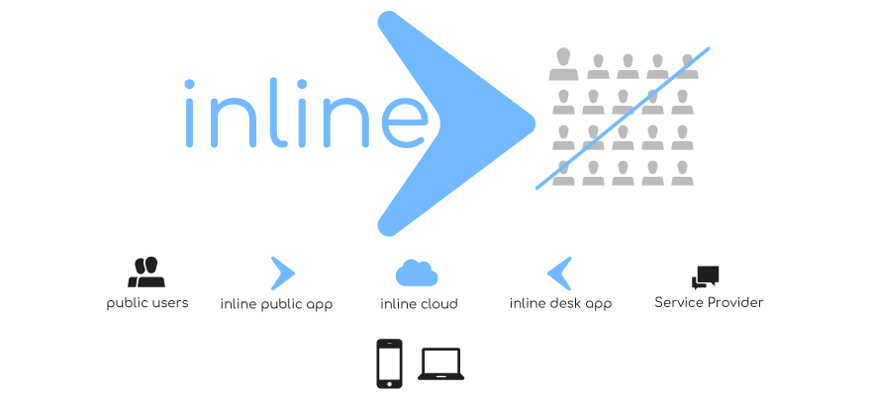
A project by Ogment Co Ltd
Due to the COVID-19 crisis, many governments around the world are putting restrictions and limits on the number of people that can gather in one place, such as banks, supermarkets, shops, pharmacies or public facilities. These measures are designed to keep everyone safe and ensure people have enough room to distance themselves from other people nearby. Due to space restrictions, maintaining social distancing in queues is sometime very difficult not to forget annoying and time consuming.
Inline QOMS is the answer to bringing technology to queueing (and saving time and effort).
Inline QOMS solves one of the most irritating daily problems which is standing in line by offering an automated smart mobile queuing app to better manage traffic/flow and save people a lot of time. Real time occupancy data has value beyond ensuring social distancing compliance. Occupancy is the missing retail metric that organisation can utilize to optimize performance but also keep customers, staffs and visitors safe. Inline QOMS can be scaled across locations and connects to our cloud platform for management and reporting. Inline QOMS comes as a free mobile application for the public to ‘get in the queue’ remotely and for businesses to handle their customer queues.

Total Project Value  MUR 544,500 | Amount Funded  MUR 502,000
Duration: 5 Weeks

