Healthlog | 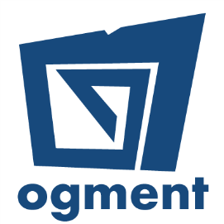

A cloud-based healthcare data management platform designed to maintain a centralised medical diary, giving access to health institutions and medical practitioners to rapidly access and update the medical history of patients so as to formulate better diagnostics and improve the efficiency of the healthcare system.
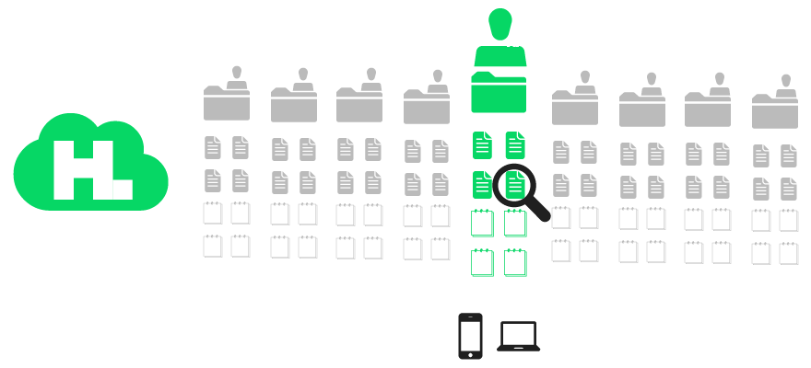
A project by Ogment Co Ltd
The onset of the COVID-19 pandemic has highlighted how fragile our health can be and the limits to which our healthcare system can be stretched. Keeping track of our health and facilitating the relaying of information to healthcare professionals when required can give us all an edge on healthcare challenges.
Healthlog facilitates the communication of crucial medical data in a timely and convenient manner. This is particularly important when seeking treatment. Often, patients have medical conditions or are under certain medications which require special attention. For example, Cardiac patients usually take Warfarin and this should be communicated every time they seek medical attention. In the context of COVID-19, it has been particularly important to identify the vulnerable and high-risk groups; people over the age of 70 and those with chronic illnesses which can weaken one’s immune system. With Healthlog, patients can simply show their mobile health cards to medical practitioners for them to access the relevant medical records.
Having access to important health information – such as immunisation records, lab results, screening due dates, allergies, prescribed medication, and other health conditions – in electronic form, makes it easy for patients to better manage their health, for medical professionals to better assist patients, and for the healthcare system to operate more efficiently.
The platform can also provide analytics for the healthcare sector and policy-makers.
Total Project Value  MUR 867,000 | Amount Funded  MUR 692,000
Duration: 6 Months

